Deploy a Highly Available Web Application on AWS
Project Overview
This project demonstrates how to deploy a highly available, scalable, and secure web application architecture on Amazon Web Services (AWS).
The infrastructure uses AWS best practices to ensure:
- High Availability
- Fault Tolerance
- Auto Scaling
- Load Balancing
- Secure Networking
- Cost Optimization
The application is deployed across multiple Availability Zones (AZs) using EC2 instances behind an Application Load Balancer (ALB).

Project Objective
Deploy a simple web application in AWS with:
- Highly Available Architecture
- Auto Scaling EC2 Instances
- Application Load Balancer
- Secure VPC Networking
- Public and Private Subnets
- Security Groups and IAM Roles

Architecture Diagram
Internet
|
v
+----------------+
| Application |
| Load Balancer |
+----------------+
/ \
/ \
v v
+-------------+ +-------------+
| EC2 Instance| | EC2 Instance|
| AZ-1 | | AZ-2 |
+-------------+ +-------------+
\ /
\ /
v v
Auto Scaling Group

Public Subnets + Private Networking

AWS Services Used
AWS Service | Purpose
Amazon EC2 | Host the web application
Application Load Balancer | Distribute traffic
Auto Scaling Group | Automatically scale instances
Amazon VPC | Isolated network environment
Internet Gateway | Internet connectivity
Route Tables | Network routing
Security Groups | Firewall rules
IAM | Secure access control
Amazon CloudWatch | Monitoring and alerts

Solution Architecture
The application architecture consists of:
Networking Layer
- One custom VPC
- Two public subnets across different AZs
- Internet Gateway attached to VPC
- Route table configured for internet access
Compute Layer
- EC2 instances running Apache/Nginx web server
- Launch Template for EC2 configuration
- Auto Scaling Group for elasticity
Traffic Management
- Application Load Balancer distributes requests
- Health checks ensure only healthy instances receive traffic
Security Layer
- Security Groups control inbound/outbound traffic
- IAM roles for secure AWS resource access

Prerequisites
Before starting, ensure you have:
- AWS Account
- IAM user with required permissions
- Basic Linux knowledge
- AWS CLI configured (optional)
- Key Pair for EC2 SSH access

Step-by-Step Deployment
Step 1: Create a VPC
VPC Configuration
Setting | Value
VPC Name | webapp-vpc
CIDR Block | 10.0.0.0/16

Step 2: Create Public Subnets
Create two public subnets in different Availability Zones.
Subnet 1
Setting | Value
Name | public-subnet-1
CIDR | 10.0.1.0/24
AZ | ap-south-1a
Subnet 2
Setting | Value
Name | public-subnet-2
CIDR | 10.0.2.0/24
AZ | ap-south-1b
Enable:
Auto-assign public IPv4

Step 3: Create Internet Gateway
- Create Internet Gateway
- Attach it to the VPC
Example Name:
webapp-igw

Step 4: Configure Route Tables
Create a route table and add:
Destination | Target
0.0.0.0/0 | Internet Gateway
Associate the route table with both public subnets.

Step 5: Create Security Groups
Load Balancer Security Group
Allow:
Type | Port | Source
HTTP | 80 | Anywhere
HTTPS | 443 | Anywhere

EC2 Security Group
Allow:
Type | Port | Source
HTTP | 80 | Load Balancer SG
SSH | 22 | Your IP

Step 6: Launch EC2 Instance
EC2 Configuration
Setting | Value
AMI | Amazon Linux 2
Instance Type | t2.micro
Key Pair | Your Key Pair
Security Group | EC2-SG

Step 7: Install Web Server
Connect to the EC2 instance:
ssh -i key.pem ec2-user@PUBLIC-IP
Install Apache:
sudo yum update -y
sudo yum install httpd -y
sudo systemctl start httpd
sudo systemctl enable httpd
Create sample webpage:
echo "<h1>Highly Available AWS Web App</h1>" | sudo tee /var/www/html/index.html
Verify:
http://EC2-PUBLIC-IP

Step 8: Create Launch Template
Create a Launch Template with:
- Amazon Linux 2 AMI
- Instance type
- Security Group
- User Data Script
Sample User Data Script
#!/bin/bash
sudo yum update -y
sudo yum install httpd -y
sudo systemctl start httpd
sudo systemctl enable httpd

echo "<h1>AWS Highly Available Web Application</h1>" > /var/www/html/index.html

Step 9: Create Application Load Balancer
ALB Configuration
Setting | Value
Name | webapp-alb
Scheme | Internet-facing
Type | Application Load Balancer
Listener | HTTP : 80
Select:
- Both public subnets
- Load Balancer Security Group

Step 10: Create Target Group
Target Group Settings
Setting | Value
Target Type | Instance
Protocol | HTTP
Port | 80
Health Check Path | /
Register EC2 instances.

Step 11: Create Auto Scaling Group
ASG Configuration
Setting | Value
Minimum Instances | 2
Desired Capacity | 2
Maximum Instances | 4
Attach:
- Launch Template
- Target Group
- Public Subnets

Step 12: Configure Scaling Policies
Example Scaling Policy:
Metric | Threshold
CPU Utilization | 70%
Actions:
- Scale Out when CPU > 70%
- Scale In when CPU < 30%

Testing High Availability
Test Load Balancer
Access:
http://ALB-DNS-NAME
Expected Result:
- Application loads successfully.
- Requests are distributed across instances.

Test Auto Scaling
Generate load using:
sudo yum install stress -y
stress --cpu 2 --timeout 300
Expected Result:
- CPU increases
- Auto Scaling launches new EC2 instance
- New instance registers with ALB

Monitoring Using CloudWatch
Monitor:
- CPU Utilization
- Network Traffic
- Healthy Hosts
- Unhealthy Hosts
- Request Count
Useful CloudWatch Metrics:
Service | Metric
EC2 | CPUUtilization
ALB | RequestCount
ASG | GroupInServiceInstances

Security Best Practices
Networking Security
- Use Security Groups instead of open access
- Restrict SSH to specific IP addresses
- Use private subnets for databases
- Enable VPC Flow Logs
IAM Security
- Use least privilege principle
- Avoid using root account
- Use IAM roles for EC2
Web Security
- Enable HTTPS using ACM certificates
- Configure WAF if required
- Keep servers patched and updated

High Availability Features
This architecture achieves high availability by:
- Deploying instances across multiple AZs
- Using Load Balancer health checks
- Automatically replacing failed instances
- Using Auto Scaling Groups
- Removing single points of failure

Cost Optimization
Ways this project reduces cost:
- Auto Scaling prevents overprovisioning
- Use t2.micro under Free Tier
- Pay only for actual resource usage
- Scale in during low traffic

Advantages of This Architecture
- Highly Available
- Fault Tolerant
- Scalable
- Secure
- Easy to Maintain
- Production Ready

Future Enhancements
Possible improvements:
- Add RDS Multi-AZ Database
- Deploy using Terraform or CloudFormation
- Use ECS or EKS containers
- Add CloudFront CDN
- Implement CI/CD Pipeline
- Add Route 53 domain management
- Configure HTTPS using ACM
- Add AWS WAF protection

Sample AWS CLI Commands
Create Security Group
aws ec2 create-security-group \
--group-name webapp-sg \
--description "Web Application Security Group" \
--vpc-id vpc-id

Launch EC2 Instance
aws ec2 run-instances \
--image-id ami-id \
--instance-type t2.micro \
--security-group-ids sg-id \
--subnet-id subnet-id

Troubleshooting
Problem | Solution
ALB showing unhealthy targets | Verify HTTP service is running
EC2 not accessible | Check Security Group rules
Auto Scaling not working | Verify CloudWatch alarms
Website not loading | Check Apache/Nginx status
SSH connection failed | Verify key pair and inbound rules

Project Folder Structure
aws-ha-webapp/
│
├── screenshots/
│ ├── vpc.png
│ ├── alb.png
│ ├── autoscaling.png
│ ├── ec2.png
│
├── scripts/
│ ├── userdata.sh
│
├── architecture/
│ └── architecture-diagram.png
│
├── README.md

Conclusion
This project demonstrates how to deploy a highly available and scalable web application on AWS using industry-standard cloud architecture.
By combining Amazon EC2, Application Load Balancer, Auto Scaling Groups, and secure VPC networking, the solution ensures reliability, fault tolerance, scalability, and security for modern web applications.
This architecture forms the foundation for enterprise-grade cloud deployments.

Author
Your Name

License
This project is licensed under the MIT License.

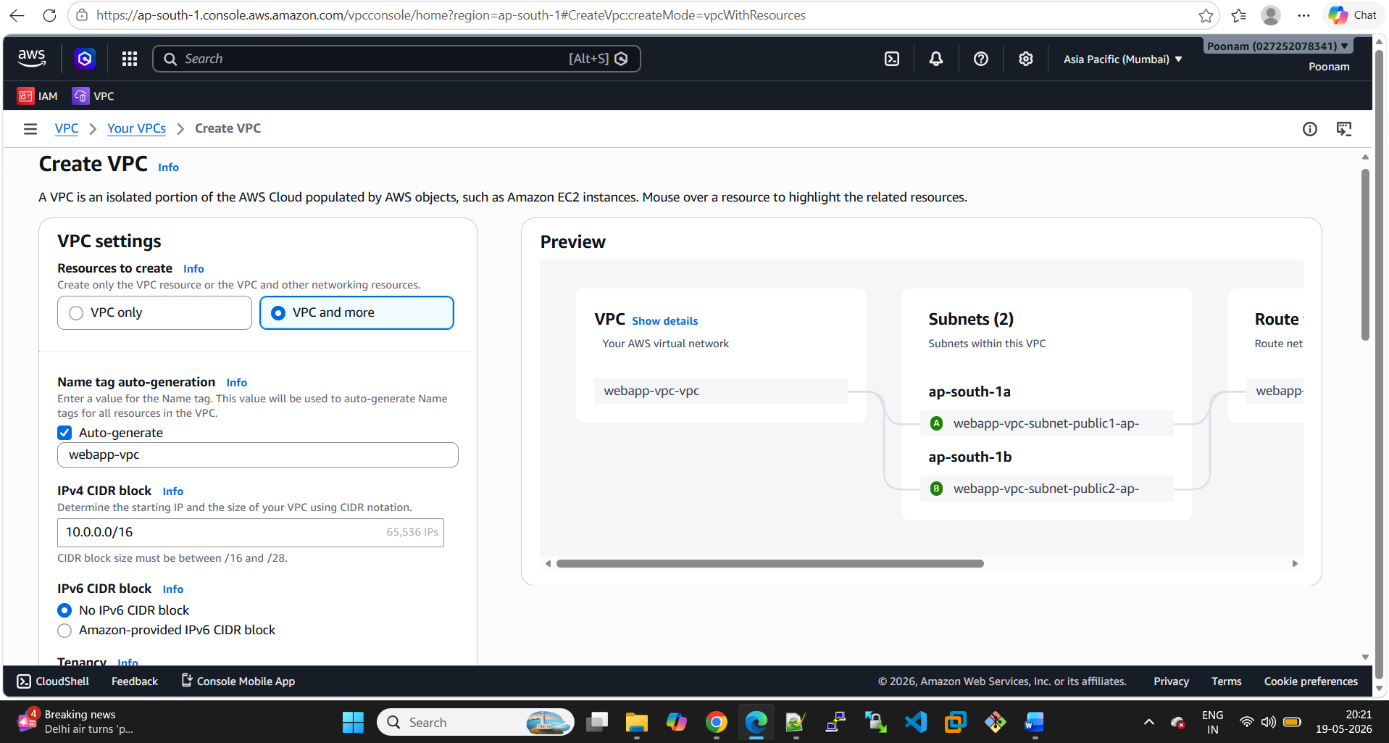

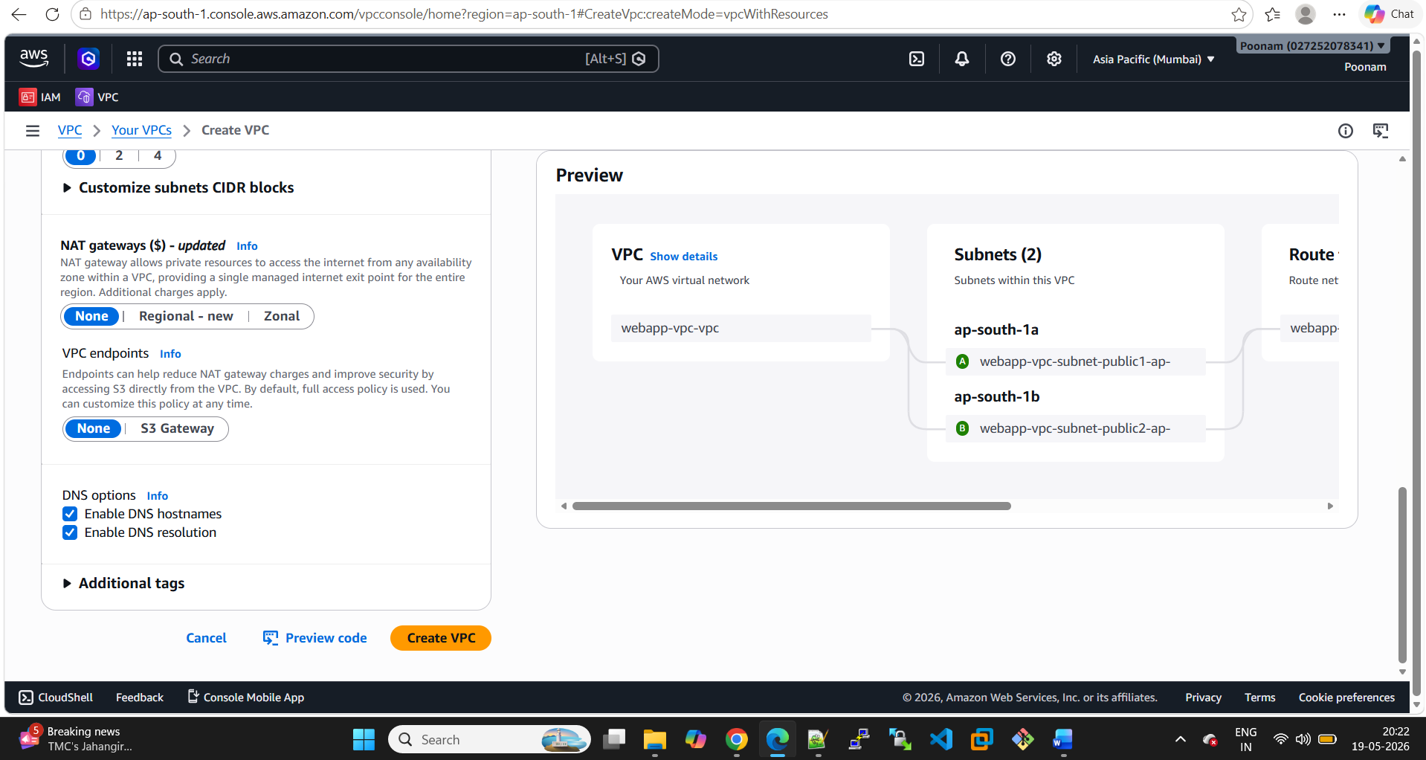

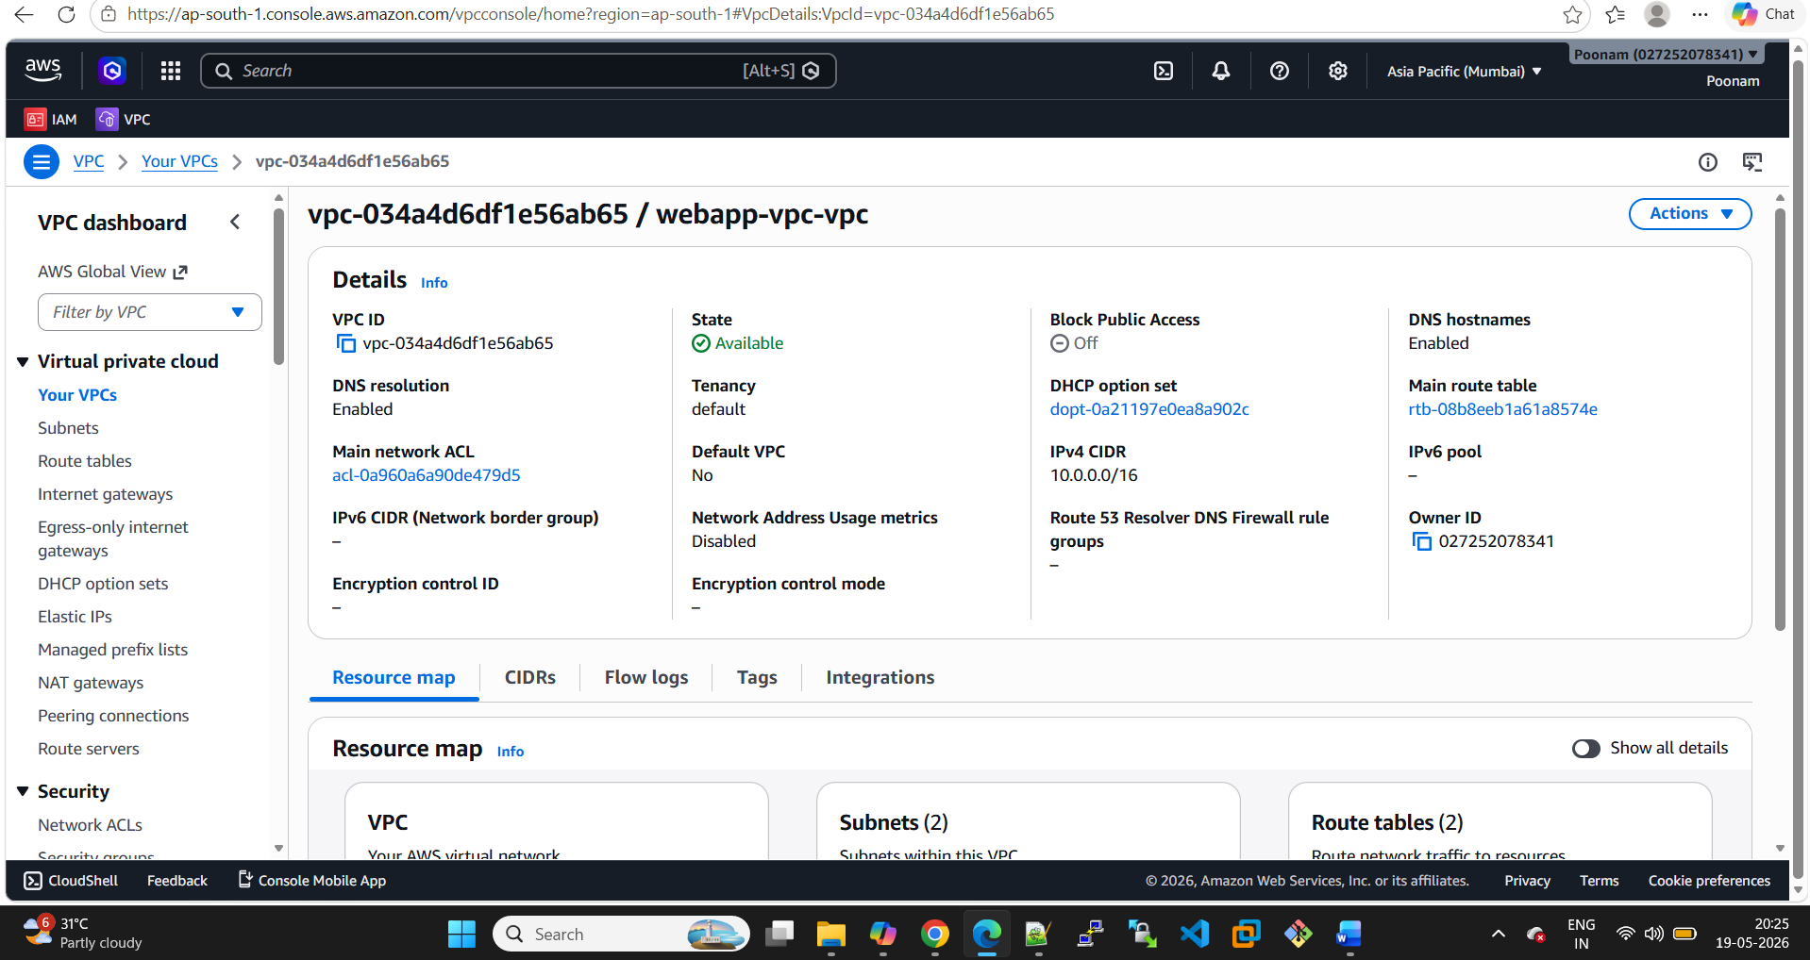

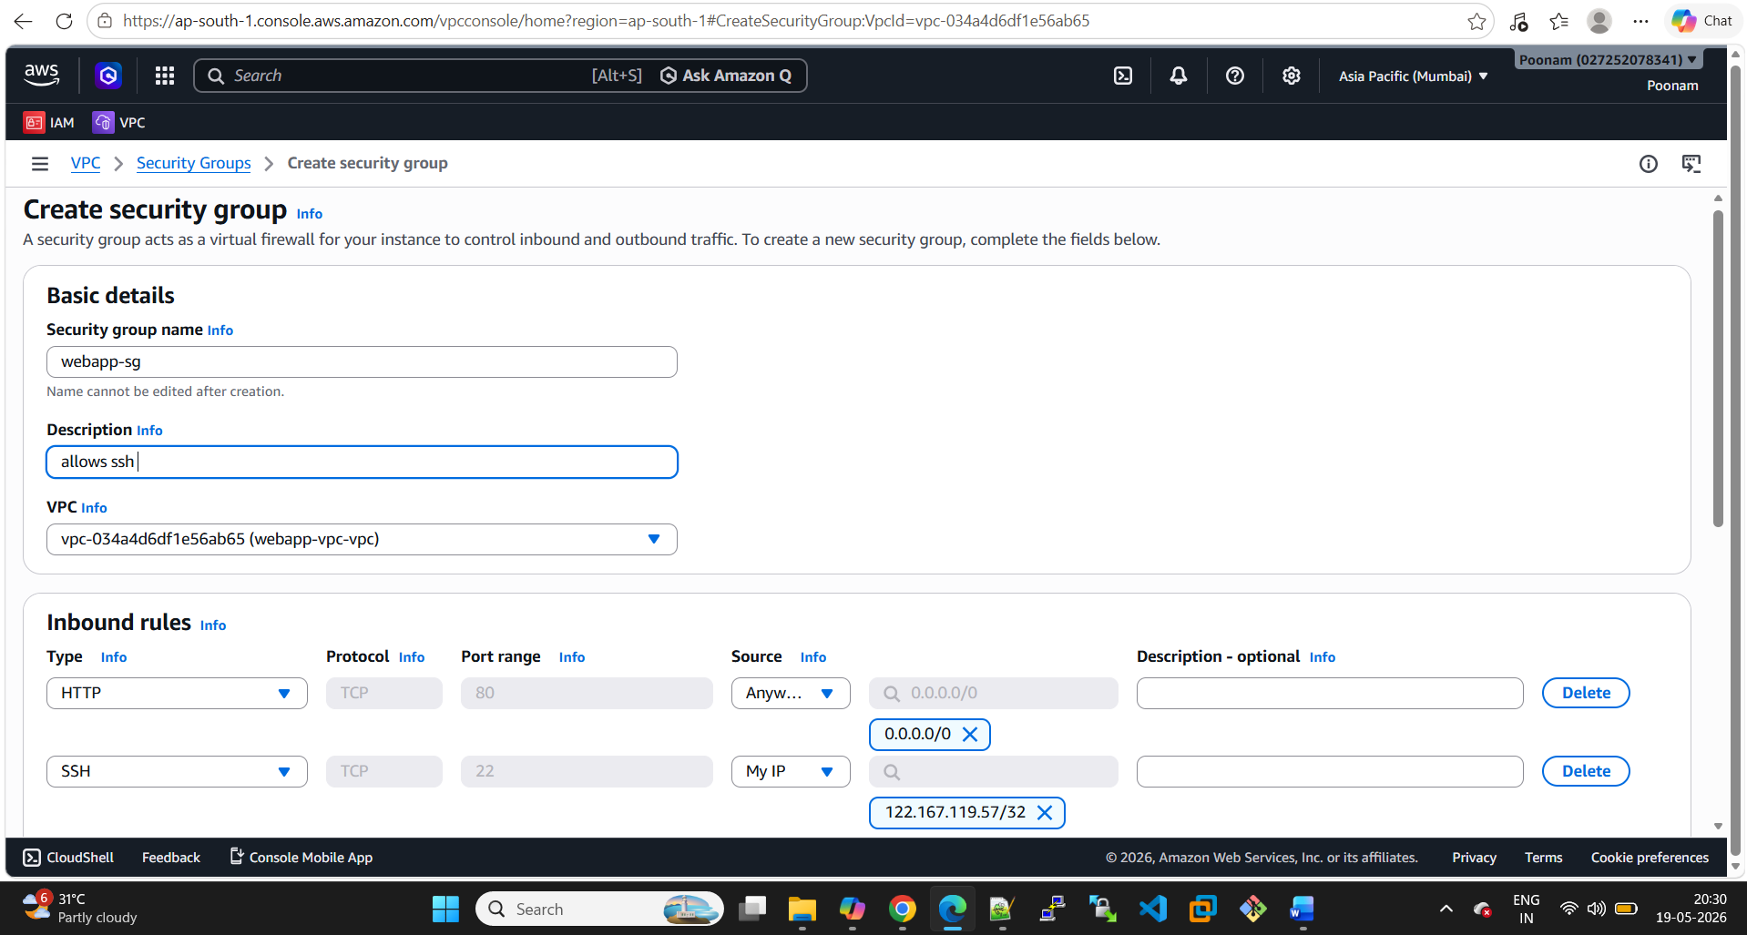

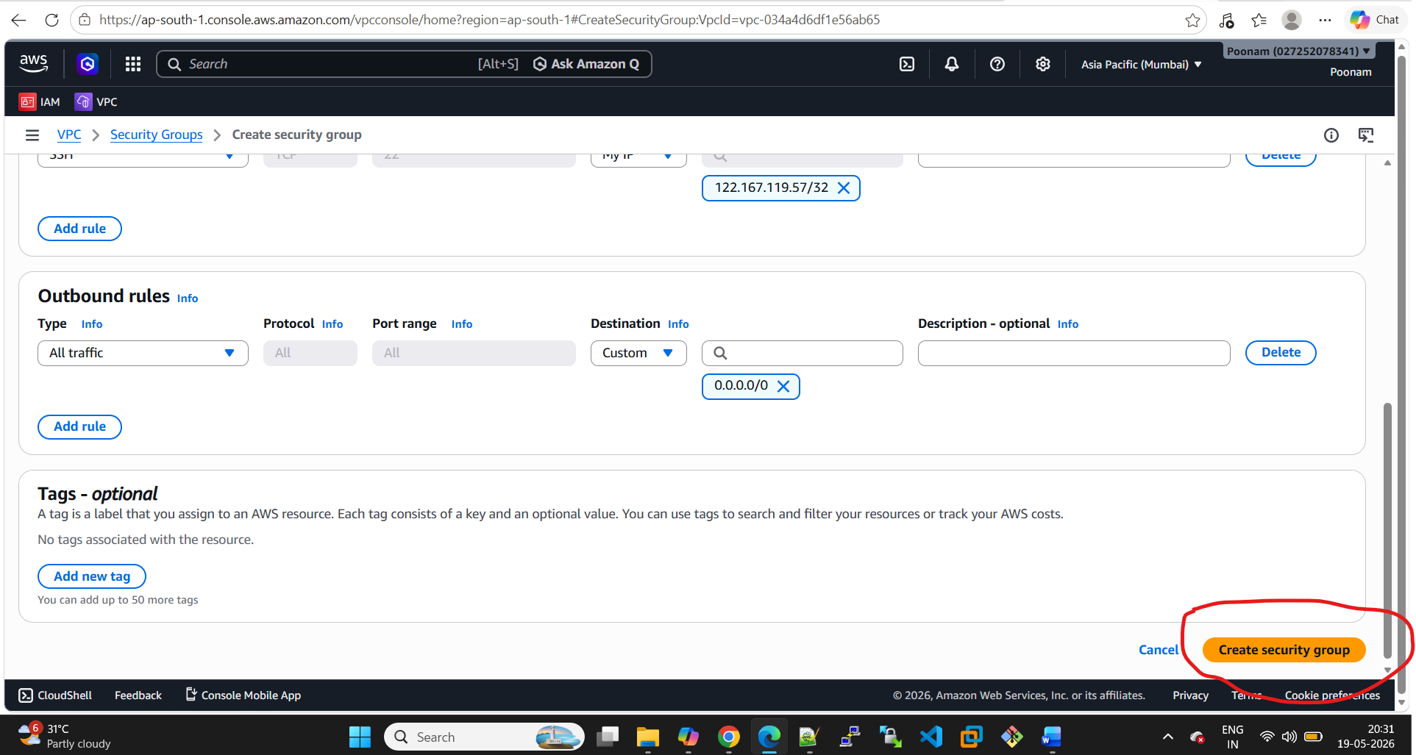
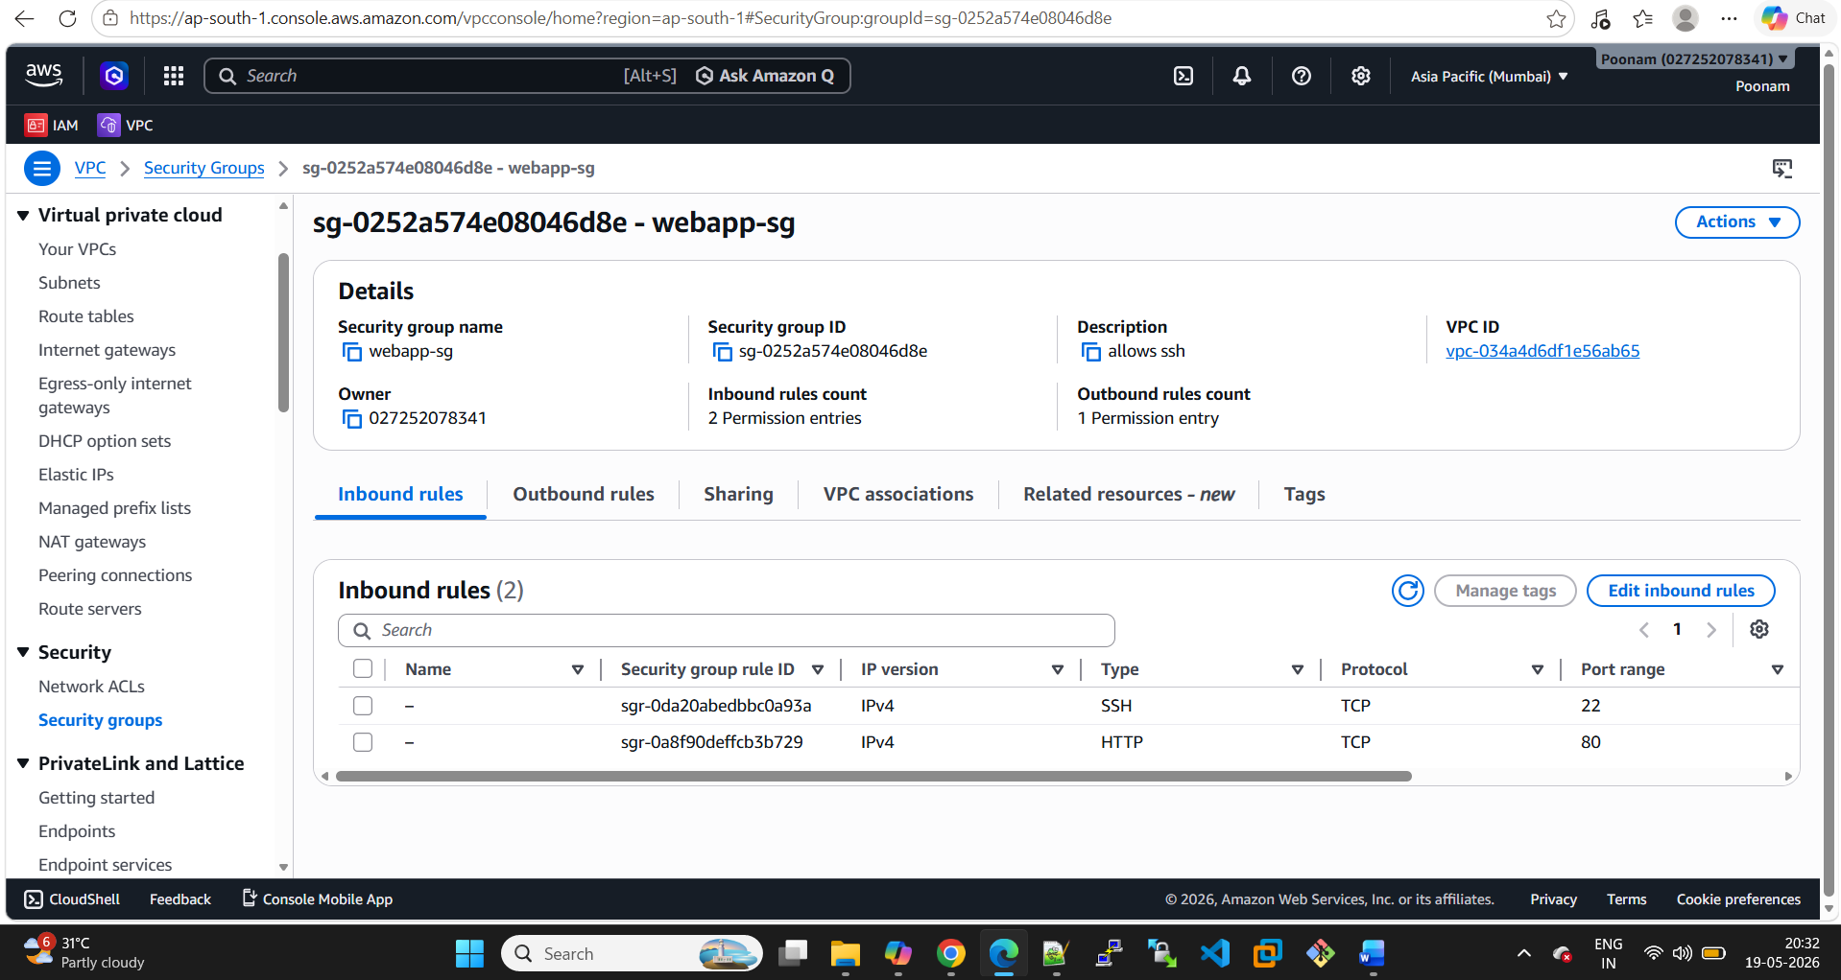
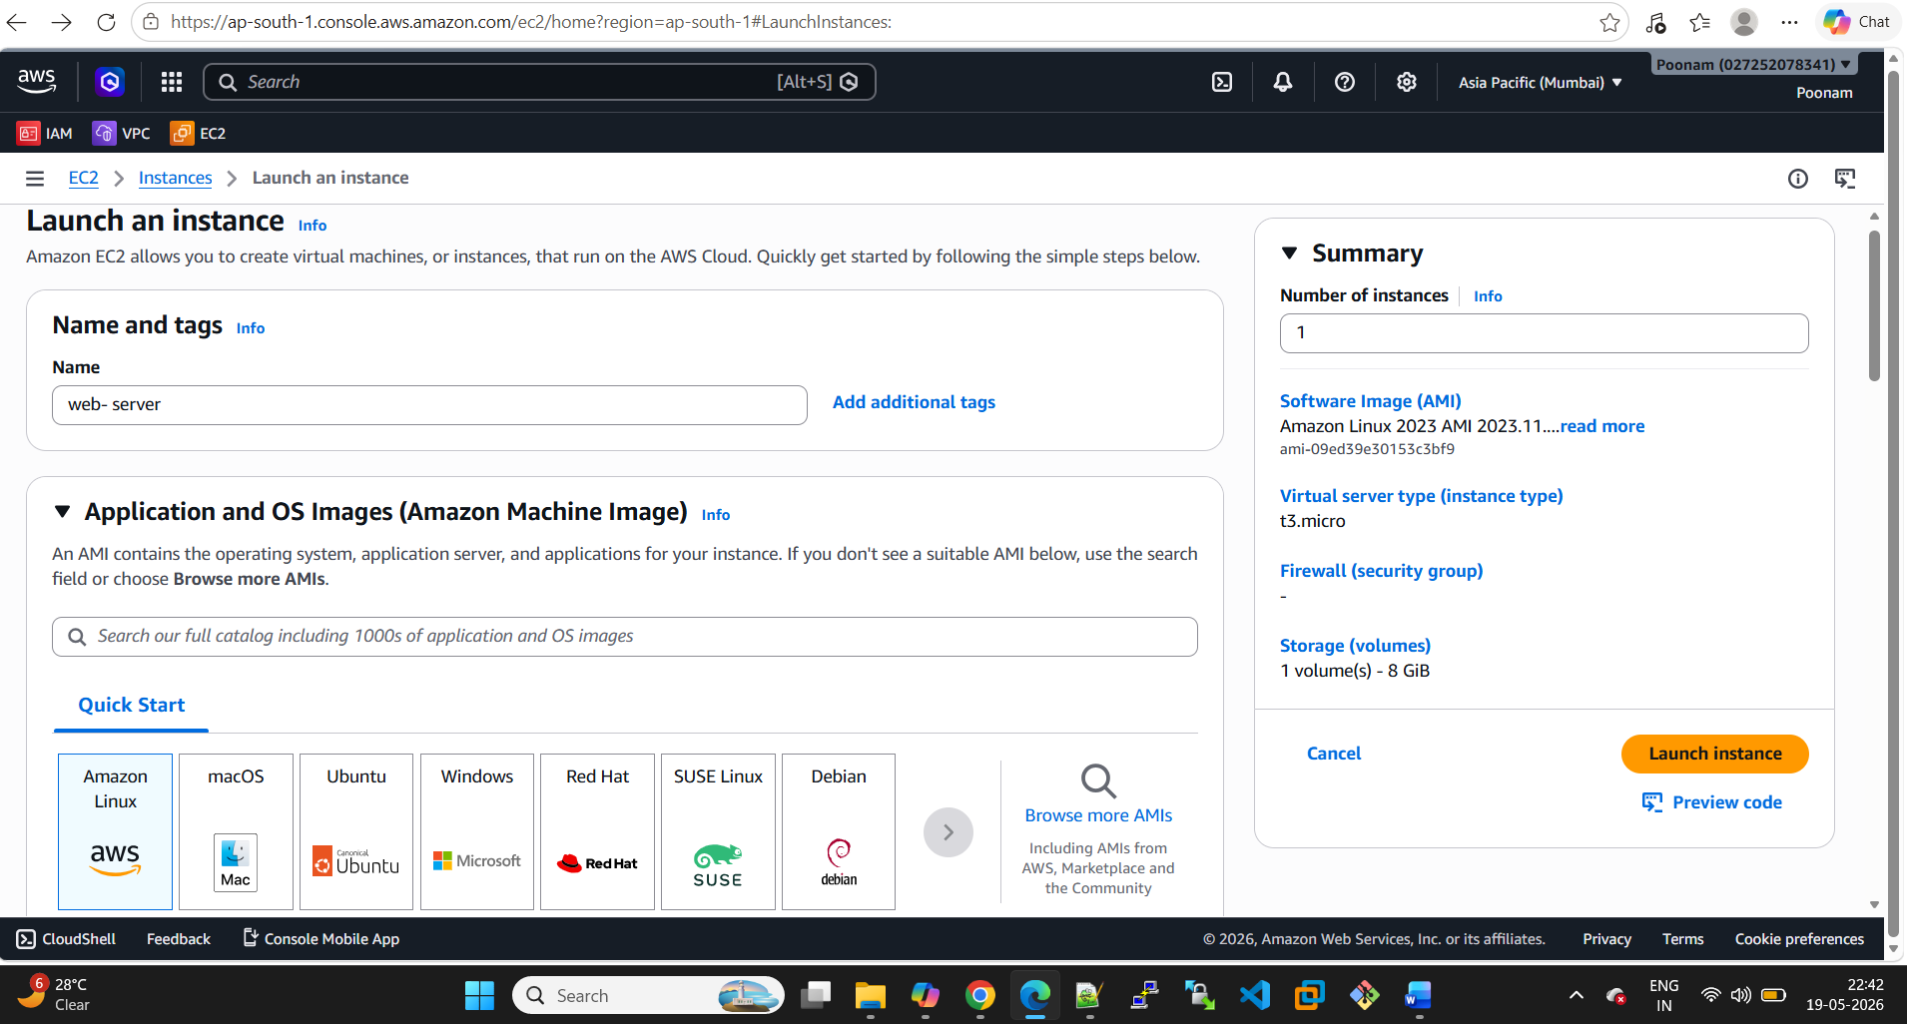

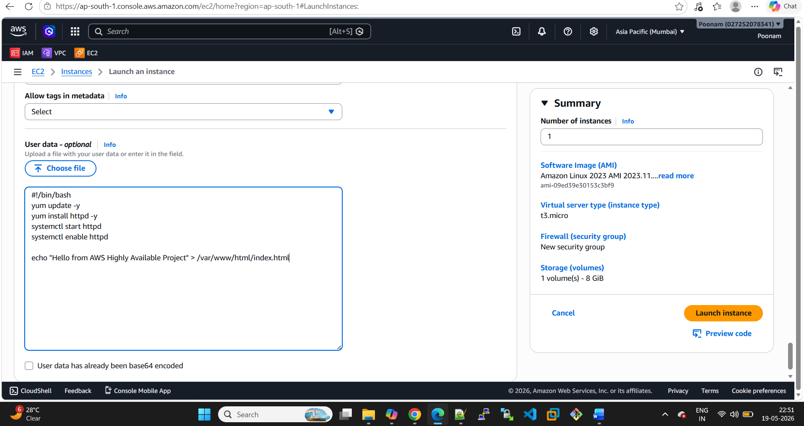

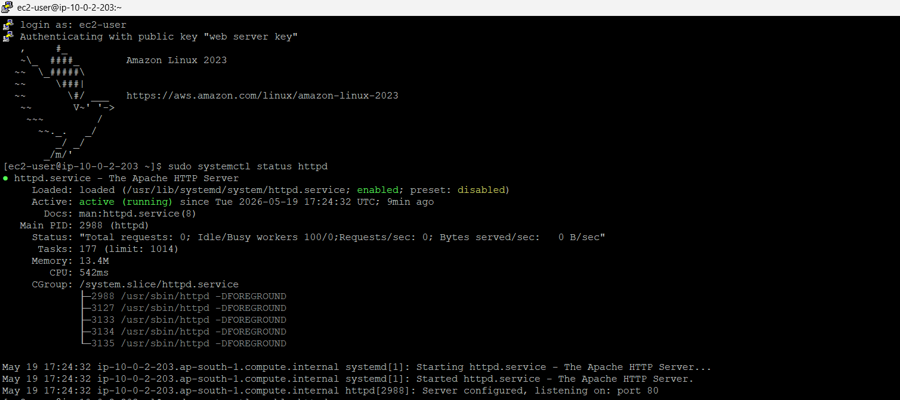
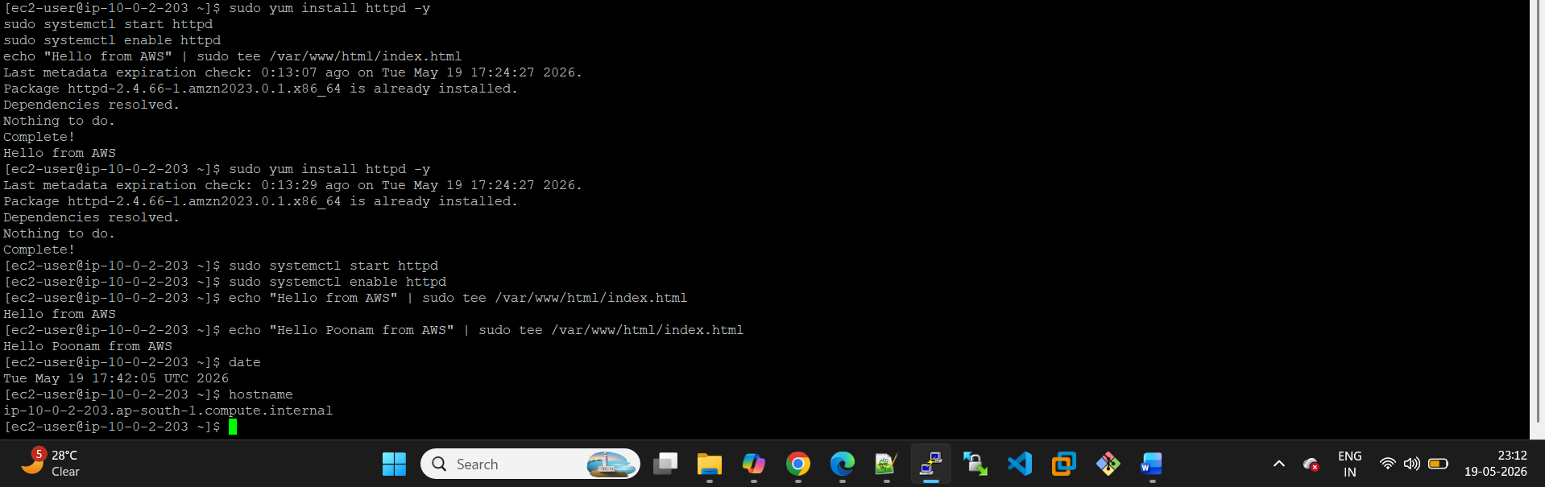





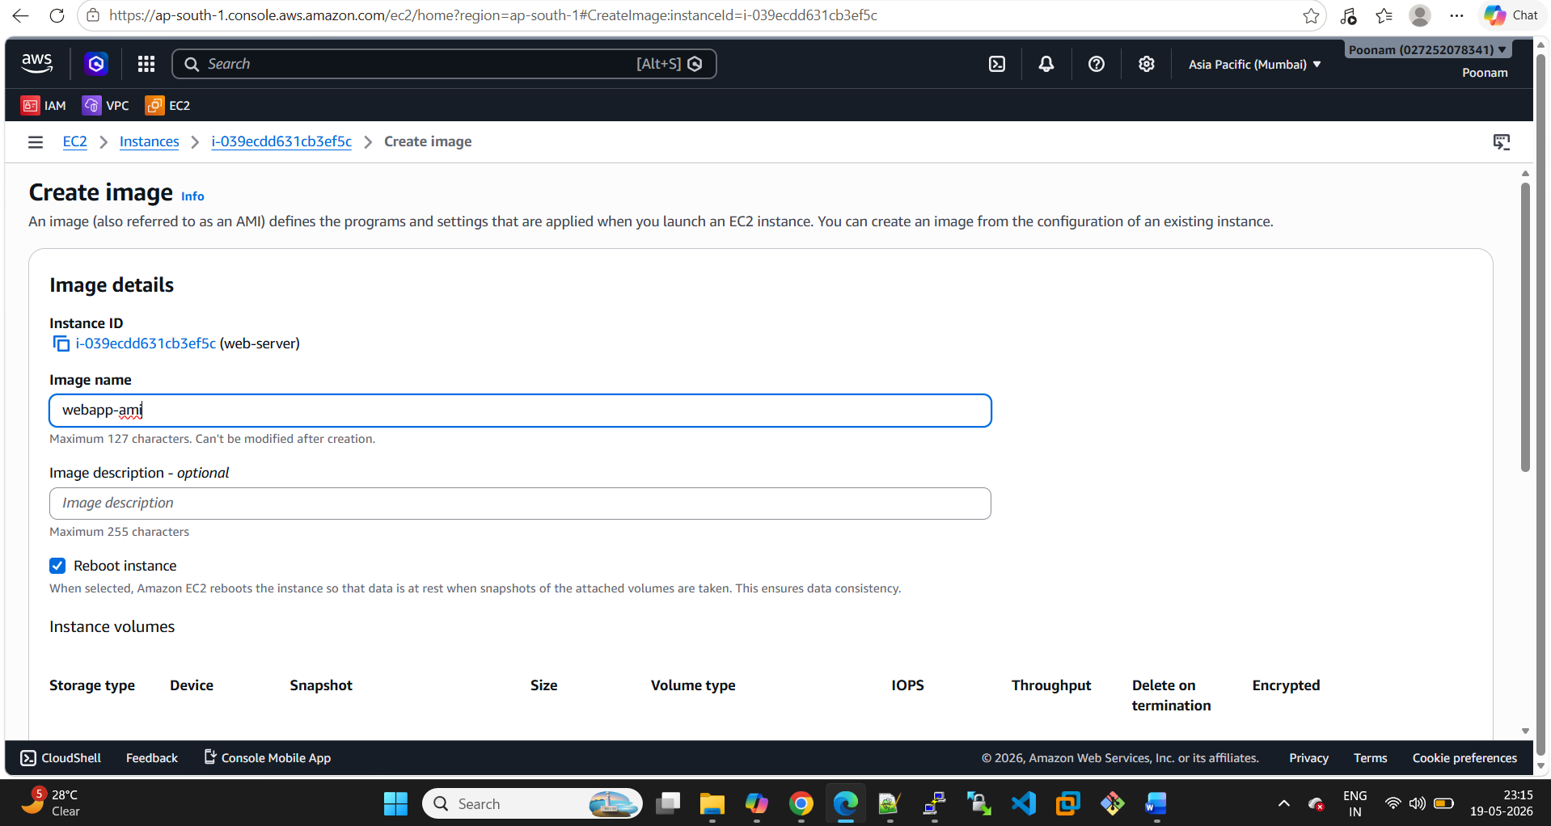

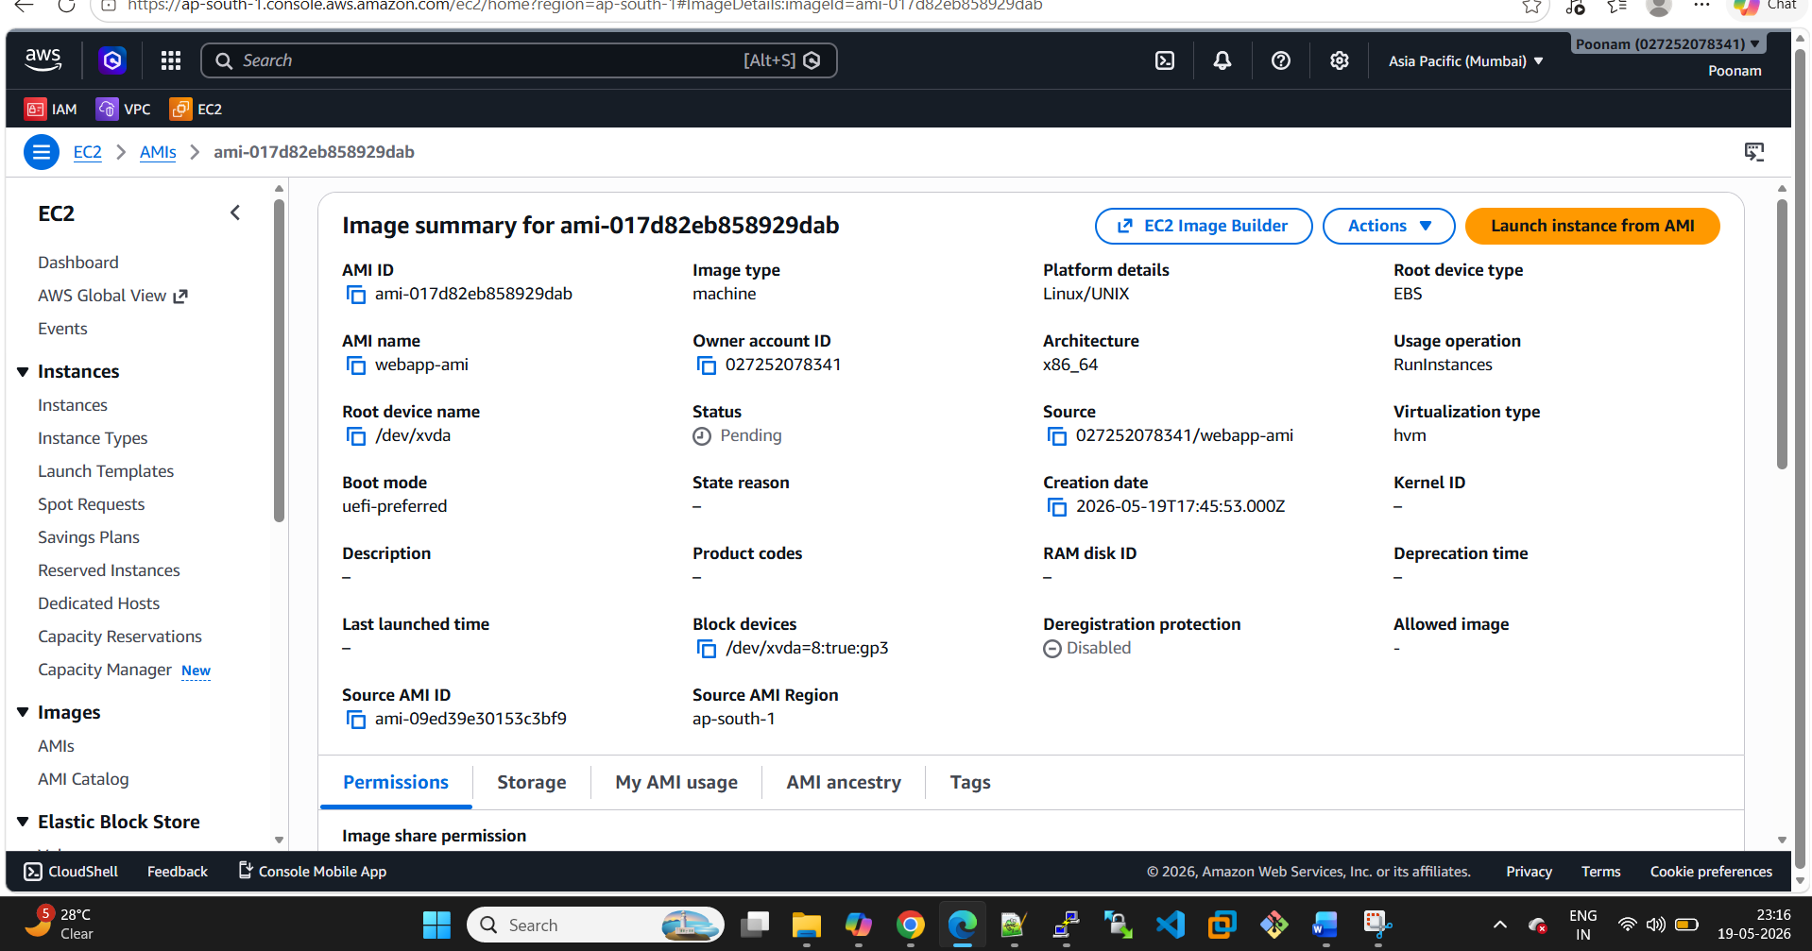

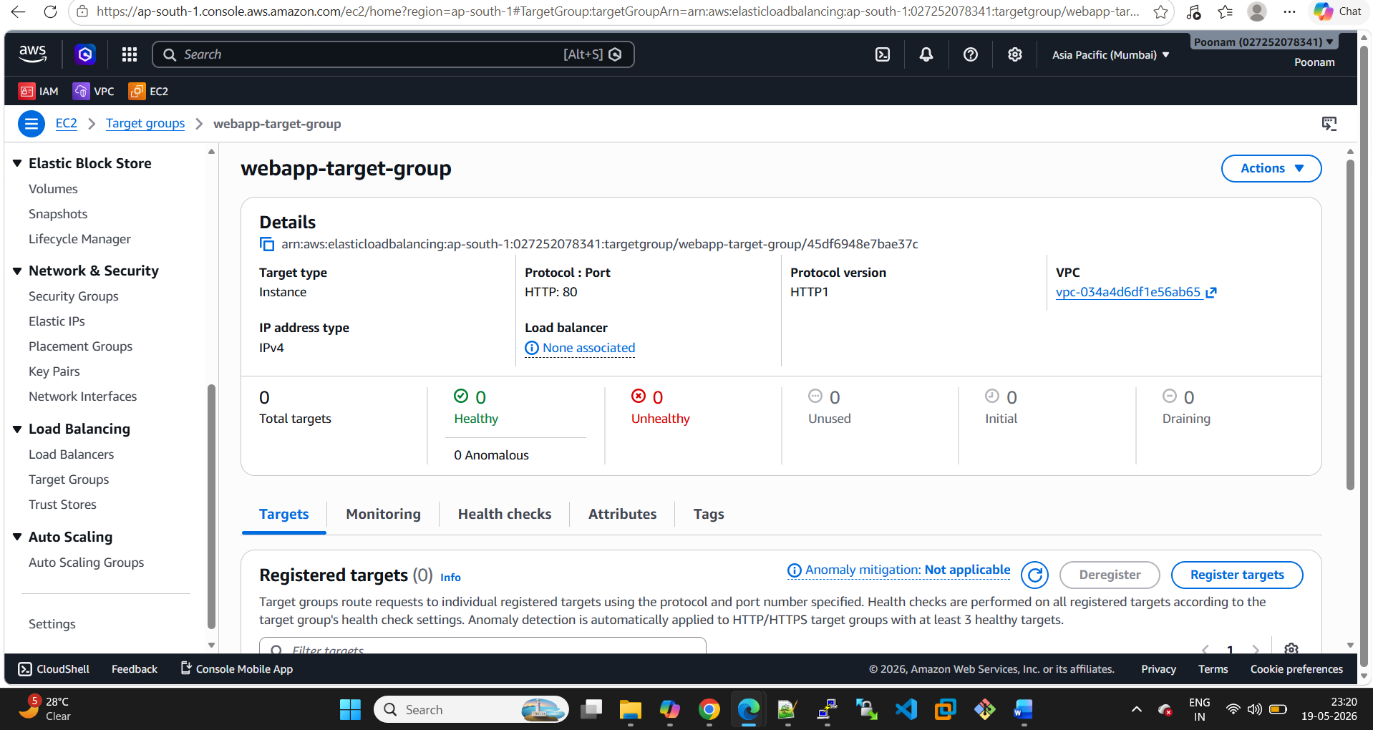

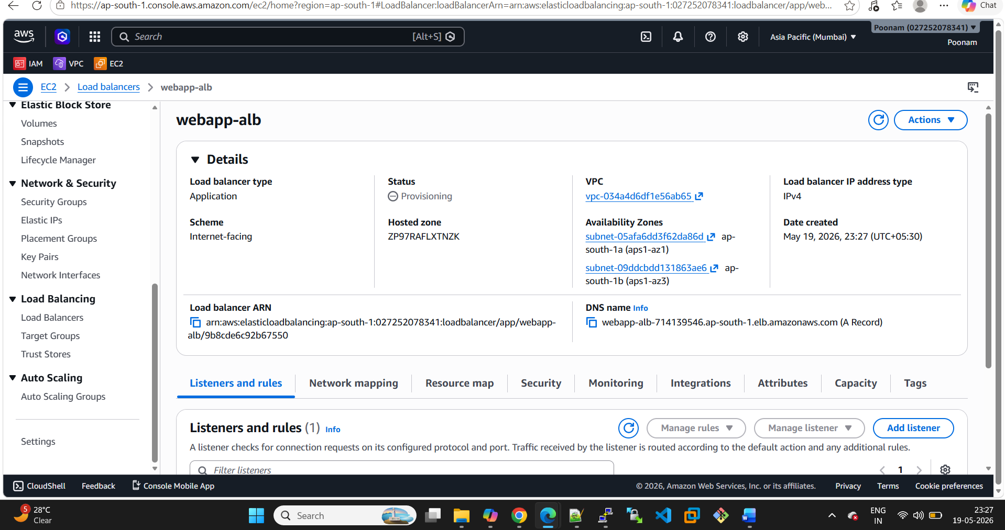

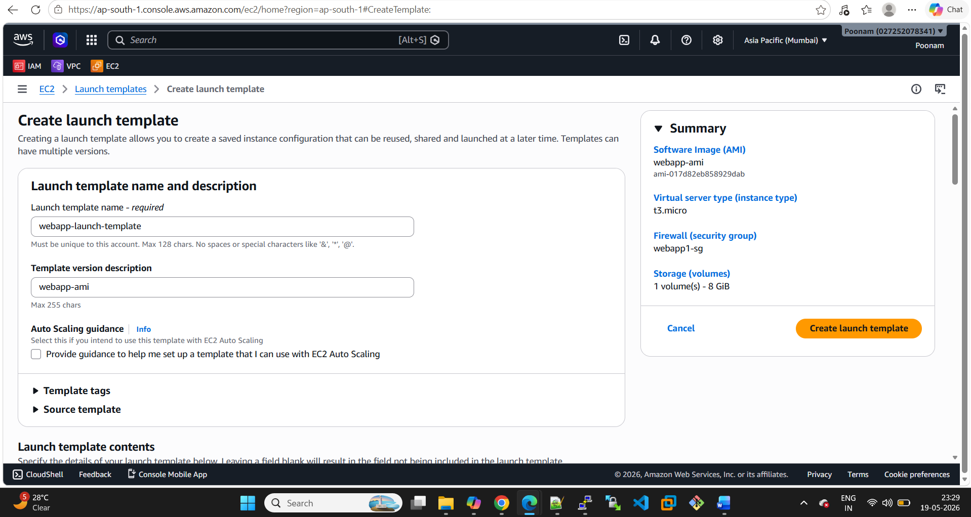

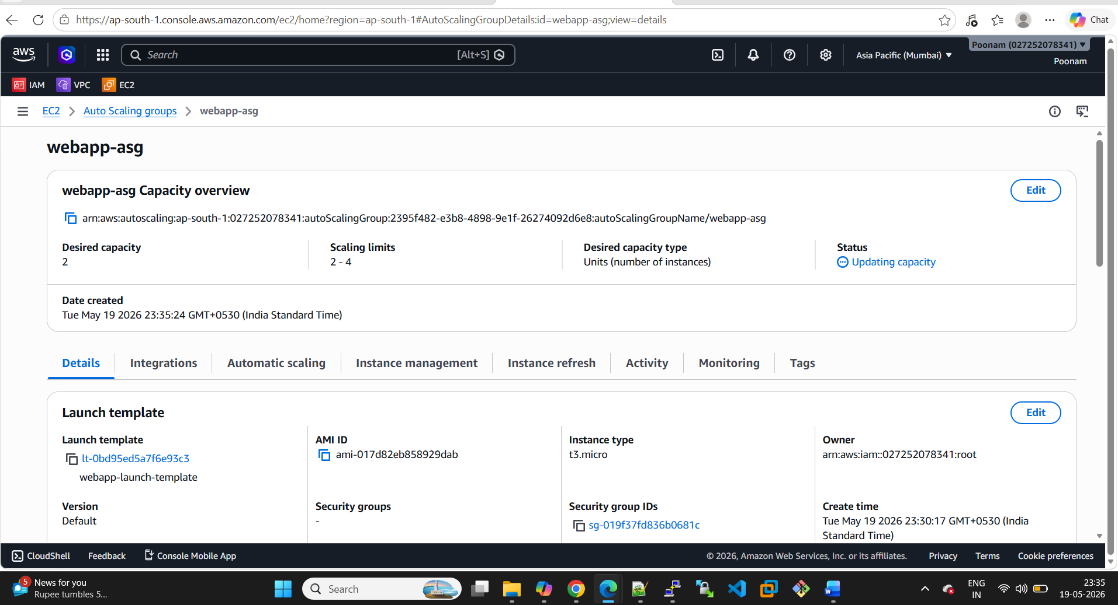
ALB working fine below


